Ch7 Problems Part 3

41. Write a query to display the customer code, first name, last name, and sum of all invoice totals for customers with cumulative invoice totals greater than $1,500. Sort the output by the sum of invoice totals in descending order (Figure P7.41)

SELECT LGCUSTOMER.CUST_CODE, CUST_FNAME, CUST_LNAME, SUM(INV_TOTAL) AS TOTALINVOICE

FROM LGCUSTOMER JOIN LGINVOICE ON LGCUSTOMER.CUST_CODE = LGINVOICE.CUST_CODE

GROUP BY CUST_CODE

HAVING SUM(INV_TOTAL) > 1500

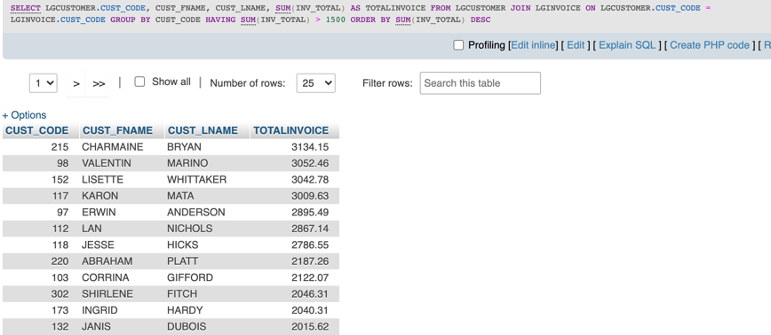ORDER BY SUM(INV_TOTAL) DESC;

1. Write a query to display the department number, department name, department phone number, employee number, and last name of each department manager. Sort the output by department name (Figure P7.42).

SELECT LGDEPARTMENT.DEPT_NUM, DEPT_NAME, DEPT_PHONE, LGDEPARTMENT.EMP_NUM, EMP_LNAME

FROM LGDEPARTMENT JOIN LGEMPLOYEE ON LGDEPARTMENT.EMP_NUM = LGEMPLOYEE.EMP_NUM

ORDER BY LGDEPARTMENT.DEPT_NAME;

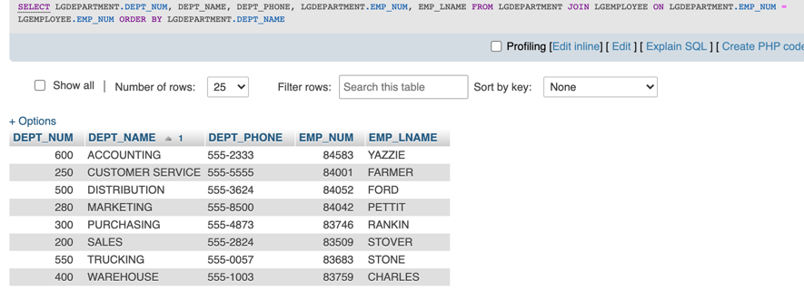

1. Write a query to display the vendor ID, vendor name, brand name, and number of products of each brand supplied by each vendor. Sort the output by vendor name and then by brand name (Figure P7.43).

SELECT LGVENDOR.VEND_ID, LGVENDOR.VEND_NAME, LGBRAND.BRAND_NAME, COUNT(*) AS NUMPRODUCTS

FROM LGVENDOR JOIN LGSUPPLIES ON LGVENDOR.VEND_ID = LGSUPPLIES.VEND_ID

JOIN LGPRODUCT ON LGSUPPLIES.PROD_SKU = LGPRODUCT.PROD_SKU

JOIN LGBRAND ON LGPRODUCT.BRAND_ID = LGBRAND.BRAND_ID

GROUP BY LGVENDOR.VEND_ID, VEND_NAME, LGBRAND.BRAND_NAME

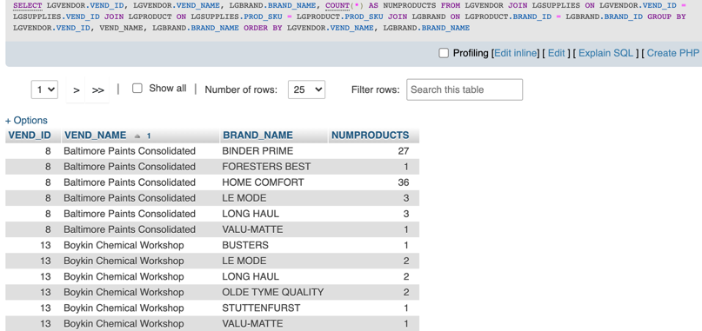ORDER BY LGVENDOR.VEND_NAME, LGBRAND.BRAND_NAME;

1. Write a query to display the employee number, last name, first name, and sum of invoice totals for all employees who completed an invoice. Sort the output by employee last name and then by first name (Figure P7.44).

SELECT LGEMPLOYEE.EMP_NUM, EMP_LNAME, EMP_FNAME, SUM(INV_TOTAL) AS TOTALINVOICES

FROM LGEMPLOYEE JOIN LGINVOICE ON LGEMPLOYEE.EMP_NUM = LGINVOICE.EMPLOYEE_ID

GROUP BY EMP_LNAME

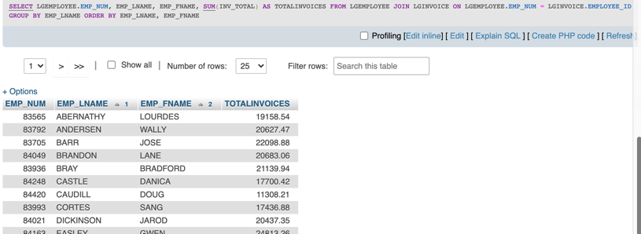ORDER BY EMP_LNAME, EMP_FNAME;

1. Write a query to display the largest average product price of any brand (FigureP7.45).

SELECT MAX(AVGPRICE) AS 'LARGEST AVERAGE'

FROM (

SELECT BRAND_ID, ROUND(AVG(PROD_PRICE),2) AS AVGPRICE

FROM LGPRODUCT

GROUP BY BRAND_ID

ORDER BY AVG(PROD_PRICE) DESC

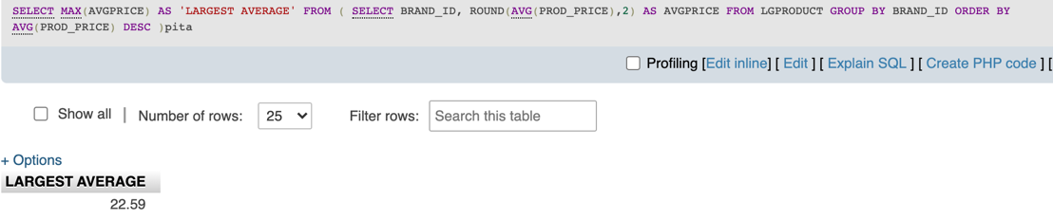 )pita;

1. Write a query to display the brand ID, brand name, brand type, and average price of products for the brand that has the largest average product price (Figure P7.46).

SELECT BRAND_ID, BRAND_NAME, BRAND_TYPE, MAX(AVGPRICE) AS 'AVGPRICE'

FROM (

SELECT LGBRAND.BRAND_ID AS BRAND_ID, BRAND_NAME AS BRAND_NAME, BRAND_TYPE AS BRAND_TYPE, ROUND(AVG(PROD_PRICE),2) AS AVGPRICE

FROM LGPRODUCT JOIN LGBRAND ON LGPRODUCT.BRAND_ID = LGBRAND.BRAND_ID

GROUP BY BRAND_ID

ORDER BY AVG(PROD_PRICE) DESC

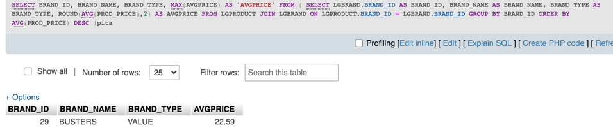 )pita;

1. Write a query to display the manager name, department name, department phone number, employee name, customer name, invoice date, and invoice total for the department manager of the employee who made a sale to a customer whose last name is Hagan on May 18, 2015 (Figure P7.47).

SELECT

m.EMP_FNAME AS 'Manager FNAME',

m.EMP_LNAME 'Manager LName',

DEPT_NAME, DEPT_PHONE,

e.EMP_FNAME AS 'Employee FName',

e.EMP_LNAME AS 'Employee LName',

CUST_FNAME, CUST_LNAME,

INV_DATE, INV_TOTAL

FROM

LGEMPLOYEE m JOIN LGDEPARTMENT ON m.EMP_NUM = LGDEPARTMENT.EMP_NUM

JOIN LGEMPLOYEE e ON LGDEPARTMENT.DEPT_NUM = e.DEPT_NUM

JOIN LGINVOICE ON e.EMP_NUM = LGINVOICE.EMPLOYEE_ID

JOIN LGCUSTOMER ON LGINVOICE.CUST_CODE = LGCUSTOMER.CUST_CODE

WHERE

CUST_LNAME LIKE '%HAGAN' AND INV_DATE = '2017-05-18';

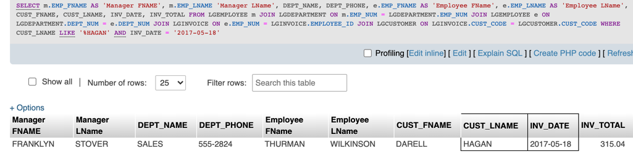

1. Write a query to display the current salary for each employee in department 300. Assume that only current employees are kept in the system, and therefore the most current salary for each employee is the entry in the salary history with a NULL end date. Sort the output in descending order by salary amount (Figure P7.48).

SELECT LGEMPLOYEE.EMP_NUM, EMP_LNAME, EMP_FNAME, SAL_AMOUNT

FROM LGEMPLOYEE JOIN LGSALARY_HISTORY ON LGEMPLOYEE.EMP_NUM = LGSALARY_HISTORY.EMP_NUM

WHERE DEPT_NUM = 300 AND SAL_END IS NULL

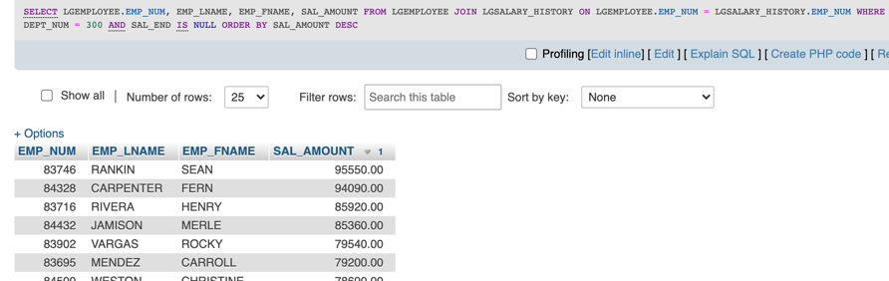ORDER BY SAL_AMOUNT DESC;

1. Write a query to display the starting salary for each employee. The starting salary would be the entry in the salary history with the oldest salary start date for each employee. Sort the output by employee number (Figure P7.49).

SELECT LGEMPLOYEE.EMP_NUM, EMP_LNAME, EMP_FNAME, MIN(SAL_AMOUNT)

FROM LGEMPLOYEE JOIN LGSALARY_HISTORY ON LGEMPLOYEE.EMP_NUM = LGSALARY_HISTORY.EMP_NUM

GROUP BY LGEMPLOYEE.EMP_NUM

ORDER BY LGEMPLOYEE.EMP_NUM;

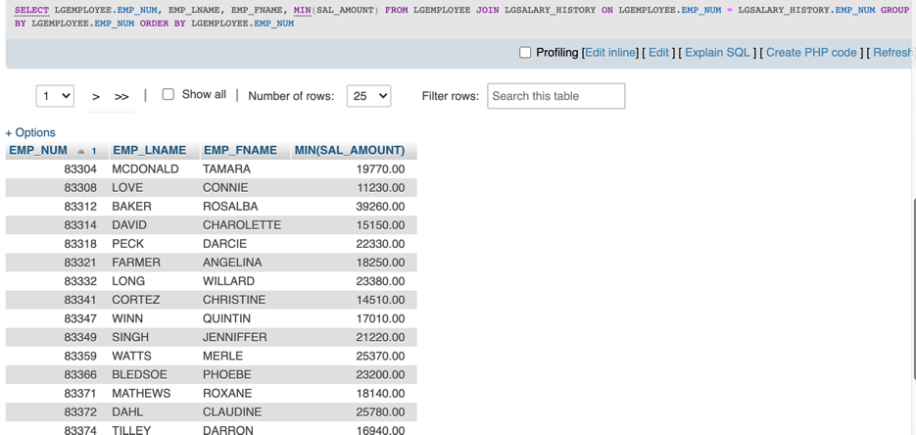

1. Write a query to display the invoice number, line numbers, product SKUs, product descriptions, and brand ID for sales of sealer and top coat products of the same brand on the same invoice. Sort the results by invoice number in ascending order, first line number in ascending order, and then by second line number in descending order (Figure P7.50).

SELECT

c1.INV_NUM,

c1.LINE_NUM AS 'p1 Line Num',

c1.PROD_SKU AS 'p1 Prod Sku',

c1.PROD_DESCRIPT AS 'p1 Prod Descript',

c2.LINE_NUM AS 'p2 Line Num',

c2.PROD_SKU AS 'p2 Prod Sku',

c2.PROD_DESCRIPT AS 'p2 Prod Descript',

c1.BRAND_ID

FROM

(SELECT l.INV_NUM, l.LINE_NUM , p.PROD_SKU , p.PROD_DESCRIPT , p.BRAND_ID, p.PROD_CATEGORY

FROM

LGLINE l JOIN LGPRODUCT p ON l.PROD_SKU = p.PROD_SKU

WHERE p.PROD_CATEGORY = 'Sealer') c1,

(SELECT l2.LINE_NUM , p2.PROD_SKU , p2.PROD_DESCRIPT , p2.BRAND_ID, l2.INV_NUM, p2.PROD_CATEGORY

FROM

LGLINE l2 JOIN LGPRODUCT p2 ON l2.PROD_SKU = p2.PROD_SKU

WHERE p2.PROD_CATEGORY = 'Top Coat') c2

WHERE c1.INV_NUM = c2.INV_NUM AND c1.BRAND_ID = c2.BRAND_ID

ORDER BY c1.INV_NUM ASC, c1.LINE_NUM ASC, c2.LINE_NUM DESC;

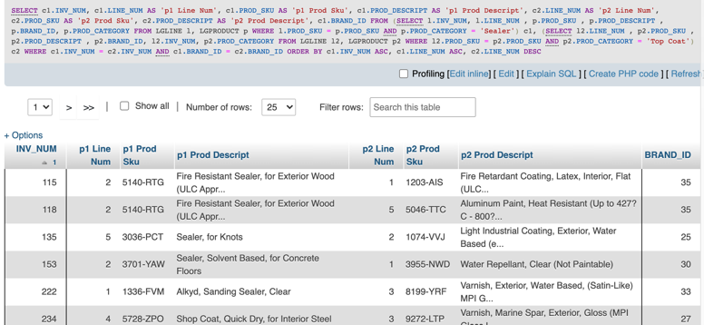

1. The Binder Prime Company wants to recognize the employee who sold the most of its products during a specified period. Write a query to display the employee number, employee first name, employee last name, email address, and total units sold for the employee who sold the most Binder Prime brand products between November 1, 2015, and December 5, 2015. If there is a tie for most units sold, sort the output by employee last name (Figure P7.51).

SELECT EMP_NUM, EMP_FNAME, EMP_LNAME, EMP_EMAIL, SUM(LGLINE.LINE_QTY) AS TOTAL

FROM

LGEMPLOYEE JOIN LGINVOICE ON LGEMPLOYEE.EMP_NUM = LGINVOICE.EMPLOYEE_ID

JOIN LGLINE ON LGINVOICE.INV_NUM = LGLINE.INV_NUM

JOIN LGPRODUCT ON LGLINE.PROD_SKU = LGPRODUCT.PROD_SKU

JOIN LGBRAND ON LGPRODUCT.BRAND_ID = LGBRAND.BRAND_ID

WHERE BRAND_NAME LIKE '%Binder Prime%' AND INV_DATE BETWEEN CAST('2017-11-01' AS DATE) AND CAST('2017-12-05' AS DATE)

GROUP BY LGEMPLOYEE.EMP_NUM

ORDER BY TOTAL DESC, EMP_LNAME

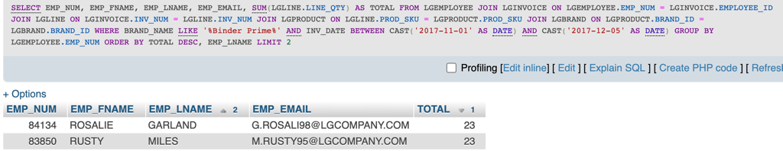LIMIT 2;

1. Write a query to display the customer code, first name, and last name of all customers who have had at least one invoice completed by employee 83649 and at least one invoice completed by employee 83677. Sort the output by customer last name and then first name (Figure P7.52).

SELECT c1.CUST_CODE, c1.CUST_FNAME, c1.CUST_LNAME

FROM

(

SELECT LGCUSTOMER.CUST_CODE, CUST_FNAME, CUST_LNAME

FROM LGCUSTOMER JOIN LGINVOICE ON LGCUSTOMER.CUST_CODE = LGINVOICE.CUST_CODE

WHERE EMPLOYEE_ID = 83649

)c1,

(

SELECT LGCUSTOMER.CUST_CODE, CUST_FNAME, CUST_LNAME

FROM LGCUSTOMER JOIN LGINVOICE ON LGCUSTOMER.CUST_CODE = LGINVOICE.CUST_CODE

WHERE EMPLOYEE_ID = 83677

)c2

WHERE c1.CUST_CODE = c2.CUST_CODE

GROUP BY CUST_CODE

ORDER BY c1.CUST_LNAME, c1.CUST_FNAME;

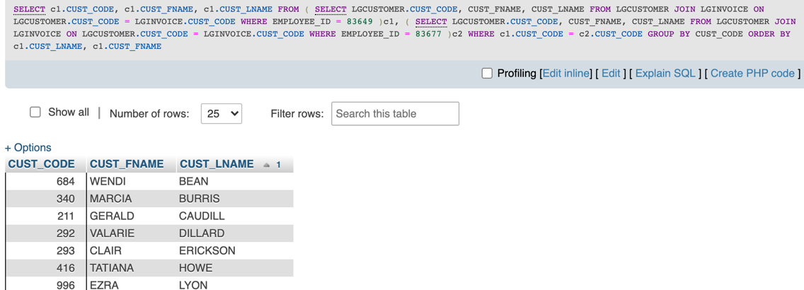

1. LargeCo is planning a new promotion in Alabama (AL) and wants to know about the largest purchases made by customers in that state. Write a query to display the customer code, customer first name, last name, full address, invoice date, and invoice total of the largest purchase made by each customer in Alabama. Be certain to include any customers in Alabama who have never made a purchase; their invoice dates should be NULL and the invoice totals should display as 0. Sort the results by customer last name and then first name (Figure P7.53).

(Our LargeCo database did not contain any Inv_Total = 0 instances)

SELECT LGCUSTOMER.CUST_CODE, CUST_FNAME, CUST_LNAME, CUST_STREET, CUST_CITY, CUST_STATE, CUST_ZIP, INV_DATE, MAX(INV_TOTAL) AS 'Largest Invoice'

FROM LGCUSTOMER JOIN LGINVOICE ON LGCUSTOMER.CUST_CODE = LGINVOICE.CUST_CODE

WHERE CUST_STATE = 'AL' AND INV_TOTAL >= 0

GROUP BY LGCUSTOMER.CUST_CODE

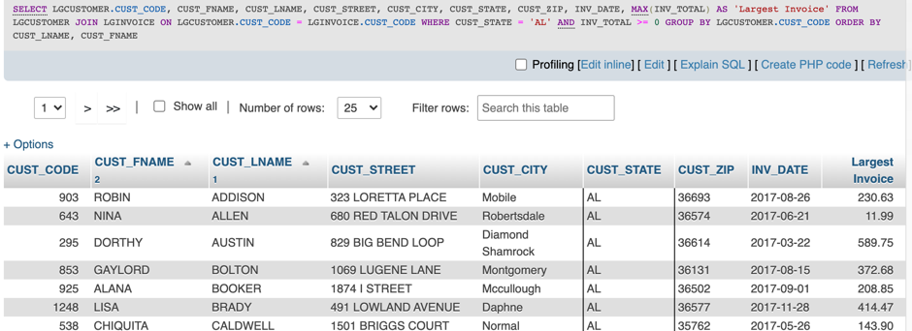ORDER BY CUST_LNAME, CUST_FNAME;

1. One of the purchasing managers is interested in the impact of product prices on the sale of products of each brand. Write a query to display the brand name, brand type, average price of products of each brand, and total units sold of products of each brand. Even if a product has been sold more than once, its price should only be included once in the calculation of the average price. However, you must be careful because multiple products of the same brand can have the same price, and each of those products must be included in the calculation of the brand’s average price. Sort the result by brand name (Figure P7.54).

SELECT BRAND_NAME, BRAND_TYPE, c1.Average_Price AS 'Average Price', c2.Units_Sold AS 'Units Sold'

FROM(

SELECT BRAND_NAME, BRAND_TYPE, LGPRODUCT.BRAND_ID, ROUND(SUM(PROD_PRICE)/COUNT(DISTINCT(LGPRODUCT.PROD_SKU)),2) AS Average_Price

FROM LGPRODUCT JOIN LGBRAND ON LGPRODUCT.BRAND_ID = LGBRAND.BRAND_ID

GROUP BY LGBRAND.BRAND_ID

ORDER BY BRAND_NAME

)c1,

(

SELECT LGPRODUCT.BRAND_ID, SUM(LINE_QTY) AS Units_Sold

FROM LGLINE JOIN LGPRODUCT ON LGLINE.PROD_SKU = LGPRODUCT.PROD_SKU JOIN LGBRAND ON LGPRODUCT.BRAND_ID = LGBRAND.BRAND_ID

GROUP BY LGBRAND.BRAND_ID

ORDER BY BRAND_NAME

)c2

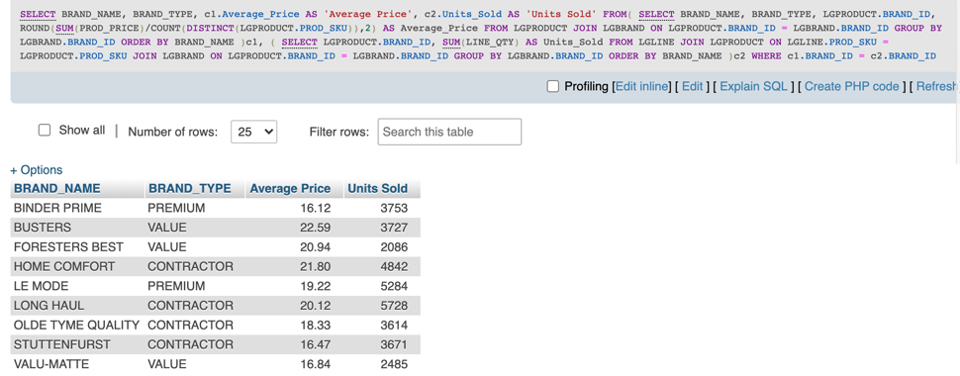WHERE c1.BRAND_ID = c2.BRAND_ID;

1. The purchasing manager is still concerned about the impact of price on sales. Write a query to display the brand name, brand type, product SKU, product description, and price of any products that are not a premium brand, but that cost more than the most expensive premium brand products (Figure P7.55).

SELECT c1.BRAND_NAME, c1.BRAND_TYPE, c1.PROD_SKU, c1.PROD_DESCRIPT, PROD_PRICE

FROM(

SELECT BRAND_NAME, BRAND_TYPE, PROD_SKU, PROD_DESCRIPT, PROD_PRICE

FROM LGPRODUCT JOIN LGBRAND ON LGPRODUCT.BRAND_ID = LGBRAND.BRAND_ID

WHERE BRAND_TYPE != 'PREMIUM'

)c1,

(

SELECT BRAND_NAME, BRAND_TYPE, PROD_SKU, PROD_DESCRIPT, MAX(PROD_PRICE) AS MAXPRICE

FROM LGPRODUCT JOIN LGBRAND ON LGPRODUCT.BRAND_ID = LGBRAND.BRAND_ID

WHERE BRAND_TYPE = 'PREMIUM'

)c2

WHERE c1.PROD_PRICE > c2.MAXPRICE

